How I run my TurtleStitch workshops

Introduction
This is a description of how I run my TurtleStitch workshops. It is by no means a suggestion that this is the ideal way. It is merely a description of what I do with the purpose to help others with potentially useful information and also an invitation to comment if you have better suggestions.
Although the suggestions could be useful for all types of workshops and lessons, I think they are especially useful for Continuous Flow Workshops as explained below.

Helper programs
I have created / am creating 5 helper programs that exclusively run on Windows (because they are programmed in AutoIT), called
- TSStart
A program that will start the default browser with the TurtleStitch page opened. Gives a TurtleStitch icon on the desktop and a records a timestamp.
- TSUSB-Label
This program can be used to sequentially label a series of (generally blank) USB sticks.
- TSUSB-Export
This program has 2 functions:
Function 1): Export the design to a TurtleStitch USB stick
Export .XML and .DST from the Downloads folder on insertion of USB stick with a volume label starting with TURTLEST. But only after checking the design for size, stitches, colors etc.
Function 2): Update files on the Desktop, the Documents folder and the Downloads folders
On insertion of a USB stick with volume label UPDATETS files to be updated are copied from the stick to the respective locations.
- TSUSB-Clean
Move TurtleStitch related content to a PC on insertion of a TurtleStitch USB stick. With a possibility to annotate / flag certain designs.
- TSUSB-Import
This program is designed to copy a .DST file on a USB stick to one or more USB connected embroidery machines.
These programs can be found at https://github.com/hansdejongehv/TSUSB including documentation how to use them.

Continuous Flow Workshops
The workshops that I do are mainly Continuous Flow Workshops. There is a setup with a number of computers to design with TurtleStitch. And one or more embroidery machines to actually embroider the work.
The workshop goes like this:
- A participant comes in and sits at a free computer.
- The participant watches an introduction video. See the end of this document for the links.
- The participant opens a file on the desktop that will start the browser with the desired TurtleStitch location (on-line or an off-line host or folder).
- The participant makes a design and can ask for support from a helper.
- When the design is finished, a helper is called to inspect the design (e.g. for density warnings) who then inserts a (generally empty) USB stick into the computer. As a program TSUSB-Export is running in the background, see below, the design is automatically exported to the stick after inspection of the design for use of multiple colors, size, amount of stitches. When all of that is within acceptable boundaries, the design (both .XML and .DST files) are exported to the USB stick, which is then automatically ejected.
- The participant chooses a piece of felt from the available set of colors.
- The participant goes to an embroidery machine with the chosen felt and the USB stick. Which embroidery machine is picked depends on the desired color of yarn. Each machine has a different color of yarn. We will not change the color of yarn in any machine, unless there is a queue of people for a particular color and another machine is idle. Then that idle machine is rethreaded with the popular color to help reducing the queue.
- A helper who operates the machine embroiders the design with some involvement of the participant, see below.
- The participant takes the embroidery and decides whether it is as desired.
  - If so, the USB stick goes into a tray with used USB sticks and the participant moves on or starts designing a new embroidery.
  - If not, the participant takes the USB stick back to any free computer – not necessarily the computer used before – and inserts the USB stick. It is detected that a design is present on the stick and then the user is prompted whether to continue with that design or not. If so, the USB stick is opened and the user can drop the .XML file on an open TurtleStitch window. The user makes changes as desired. When completed, the steps are repeated until the result is as desired.

Who operates the embroidery machine?
I generally let participants at least insert the USB stick, press the start button and at the end get the felt out of the hoop and then get the USB stick out of the machine. If there is time they can also put the felt in the hoop, let them lower and raise the presserfoot, but when the helper is in a hurry (e.g. one helper attending 4 machines) then the helper does it. With lowering and raising the presserfoot the helper has to well instruct the participant to lower it gently and that takes a bit more time.
What I always let the helper do is to attach the hoop to the machine as well as remove it, because my experience is that even for the helpers this is not always so easy. And rethreading we do not do at all and that is something not even all helpers will do when the thread breaks. I do though, when rethreading is needed, let the participant carefully watch the process of inserting the thread in the needle and sometimes even let them operate the knob to do so. This is also depending on which machine it is. Some of my machines are more delicate than others.

Using one USB stick per participant
I use a separate USB stick for each participant. The used USB sticks end up in a tray at the embroidery machines. When running out of empty USB sticks or at the end of the workshop, the used ones are taken to a separate laptop to move the designs off the USB stick. These designs are saved in case we would later like to look at them. I use the program TSUSB-Clean to run this process quickly: insertion of the USB stick will automatically move the TurtleStitch content to the laptop and eject the USB stick. So, insert the stick, wait for a message and remove the stick. The process takes no more than some 10 seconds per stick.
TSUSB-Clean also allows for annotating the design, e.g. if someone asks for the design to be sent, you can add that information during the cleaning process and later find it back easily.
The advantage of a separate stick for every design is that at the embroidery machine it is always clear which design to embroider as there is only one design at each stick.
If the participant wants to update the design, the participant goes to any available computer and inserts the USB stick. The program TSUSB-Export will detect that there is a design on the stick already and gives the opportunity to open the design for updating, see the documentation of TSUSB-Export.

How many resources are needed?
I would love to have a formula for this, but for now I can only give some experience figures.
Event | When | PCs | Embroidery machines | Helpers | Result
Open Day at djoe (De Jonge Onderzoekers Eindhoven) | 29 March 2026 | 10 | 4 + 1 spare which was needed | 3 experienced | Did not count the embroideries. It was very busy at times. Helpers could manage OK.
Maker Festival Twente (MFT) in Enschede | 7-10 May 2026  12:00 – 17:00 | 15 (10 on 7 May) | 4 + 1 spare which was needed | 3 experienced (2 on May 7th )  1 non-experienced | On the 4 days there were resp. 20, 38, 32 and 51 embroideries made.  It was busy at times, but the helpers could manage
Night University Junior in Tilburg | 12 May 2026  15:30 – 19:30, in practice till about 20:30 | 19 | 6 | 3 experienced  3 non-experienced | There were some 100 embroideries made.  It was very busy for the helpers, but it worked out. More helpers would have been welcome

Running off-line or on-line
TurtleStitch can be run on line via turtlestitch.org/run or locally on the computer.
When running on-line, the resulting designs can be stored in the cloud or locally on the computer.
Both setups have advantages and disadvantages. This is discussed below.

Advantages of off-line
- No need to have a stable internet connection.
- No need to always have the OS of the computer, e.g. Windows, updated to the latest version and patches.
When you have a set of computers that you use for your workshops, then going through the hassle of updating each computer to the latest version each time you want to run a workshop can be quite time consuming. When running the workshop on off-line computers there is no need to have the latest version updates, which you would want to have for security reasons when running on-line.
- No surprises that something in TurtleStitch has been changed and does not fit your teaching material anymore.
We have seen that some translations are updated in a next version and in that way can be out of sync with the training material that you may use.
- No distraction of participants who are going to look on the internet, play movies, go to sites with adult content etc.

Advantages of on-line
- Easiest setup. No need to copy TurtleStitch files locally.
- Ability to store designs in the cloud.

Advantage of storing designs locally
- The design can go with the USB stick and then it is handy when the participant returns to another computer to change the design.
- Do not garble up the cloud with all experimental designs.
- No need to make TurtleStitch accounts or use TurtleStitch group accounts.

Advantage of storing designs in the cloud
- The participants can look at each other’s work in the gallery.
- Nice designs are then available for others in the community to continue on.
- It adds to the usage statistics of the site.
- It is a way to transfer designs to a central machine that connects to the embroidery machines in case USB is forbidden on the participant’s PCs.

How to run when no USB sticks are allowed in participants PCs
This is described in broad terms because I have not yet encountered the situation where USB sticks are not allowed. The flow below is what I can of now think of, but we need to look in more detail of how this could work.
- Upload to cloud
- Note that no .DST file can be uploaded, so the design needs to be reproduced at the central PC
- Or copy .XML and .DST via an own local network to an own local server and let the teacher pick it up from there.

How to use
- Although it can be done differently by opening a browser and typing a URL, the nicer way is to put a flavour of TSStart.exe on the desktop and rename it to TurtleStitch.exe. In that way you can always refer in your teaching material to the same name and icon regardless of the actual setup. The flavours are:
  - TSStart-Remote For when TurtleStitch is used remotely, so open turtlestitch.org/run.
  - TSStart-LocalHost For when TurtleStitch is used with a local host.
  - TSStart-LocalFile For when TurtleStitch is using a local file.
- Give a number of USB sticks a volumelabel TURTLESTnn, where nn can be anything but generally it is a sequence number. TSUSB-Label can be used for that when it is ready.
- Put TSUSB-Export.exe somewhere on the computer.
- Determine whether you want to use the default values for TSUSB-Export or place and update the TSUSB-Export.ini file. See the documentation of TSUSB-Export for details.
- Start TSUSB-Export
  - Execute by double clicking, or
  - Let it automatically start when the user logs on, see the documentation of TSUSB-Export.
- Make TurtleStitch available from the PC
  - When starting TurtleStitch remote nothing needs to be done. You will just use the URL https://turtlestitch.org/run, possibly via the renamed TSStart-Remote.exe.
  - For setting up TurtleStitch in an offline mode (with localhost or in a folder), see the separate document.
- Install TSUSB-Clean on a separate PC used for cleaning up the USB sticks.

Counting usage
At the end of an event the question of the organisers is often how many visitors there have been.
In TSUSB-Clean it can be determined, after all USB sticks have been cleaned, how many participants have embroidered by counting the number of files.
The number of embroideries made can be counted by also including the backups made. If everything is done as it should, those are the original files of the participants who modified their design after the embroidery.
TSStart.exe will write a timestamp into a file when it starts and TSUSB-Export will write a timestamp in as well. In that way it is possible to also determine how many participants started a design but did not complete it. As well as how long time the designs took.
For knowing the amount of visitors, you will have to look at the amount of participants and make a guess about how many people accompanied them. E.g. if on average every participating child came with one parent, then multiply the number of participants by 2 to get the amount of visitors.

USB and audio cables
It depends on the PC that is used, but I find it handy to use short (10 cm or so) USB extension cables that have a 90 degree connector for the mouse and the USB sticks. I also connect the headset with a 90 degree connector so that there is more room to the side of the laptop for mouse and papers.
<< picture to be provided >>
Also for the embroidery machine I use those extension cables so that there is less wear and tear on the USB connectors of the machine and less chance to bump into the plugged in USB stick. Note that different machines need a 90 degree connector that goes to the right while others need a 90 degree connector that goes to the left.
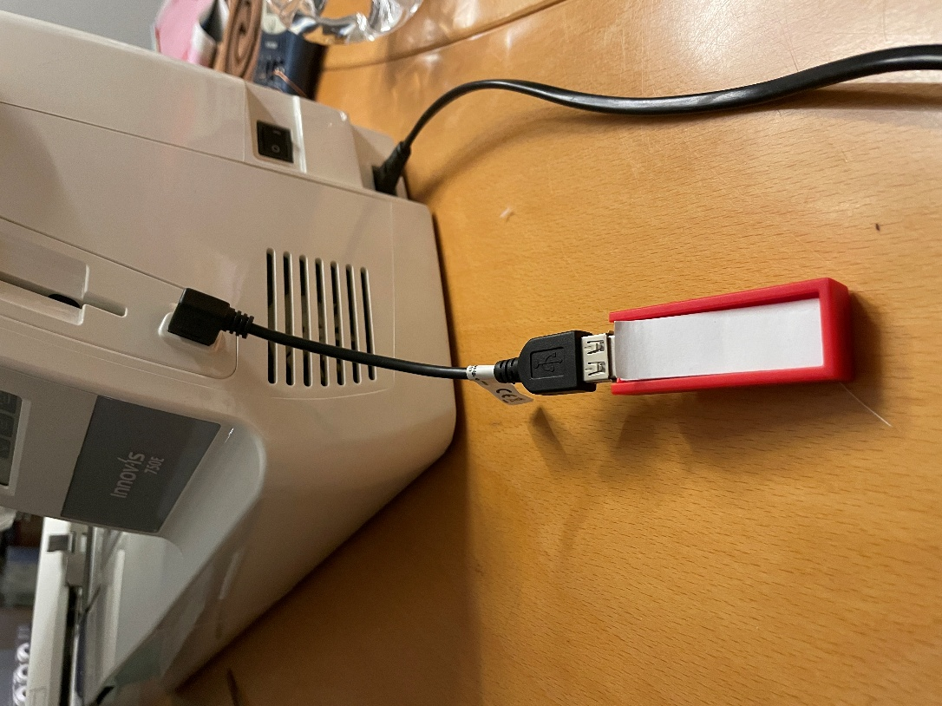

Examples
I have 28 examples of what can be made with TurtleStitch. Those I hang over the crates with felt.
I also have examples of 9 colors of yarn on 19 colors of felt. Those are hung from a lath on a speaker stand.
See the picture below with the examples of what can be made to the left and the examples of yarn and felt to the right. It is only done when there is sufficient room to set it up.
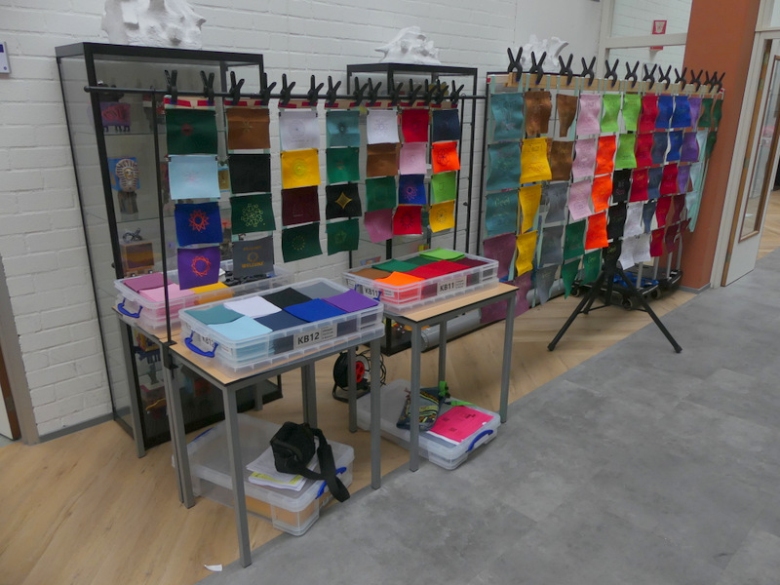

Further displays
I have a banner in Dutch and one in English that I set up when there is room for it. It helps to explain to passers-by what TurtleStitch is.
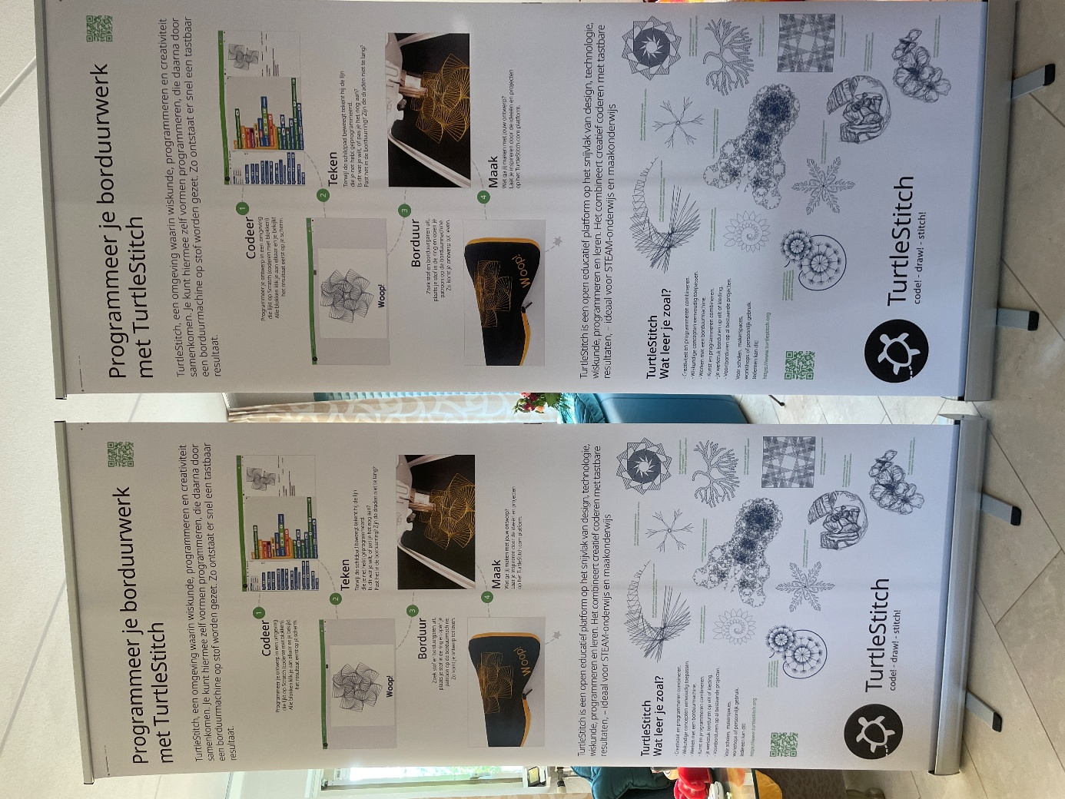

Instruction movie
I have an instruction movie that I display on a large screen in a continuous loop. It is also available for the participants on the laptops. There is a Dutch and an English version.
- TurtleStitch Demo Dutch
https://www.youtube.com/watch?v=rpFlkvAaR1U
- TurtleStitch Demo Engels
https://www.youtube.com/watch?v=li90Ret7eOI

Handouts
Depending on the location of the workshop, I have these handouts prepared:
- A single sheet with how to continue at home, where to find a place where to further learn TurtleStitch and a list of nearby places where an embroidery machine may be found.
- TurtleStitch business cards.
- My own business cards.

